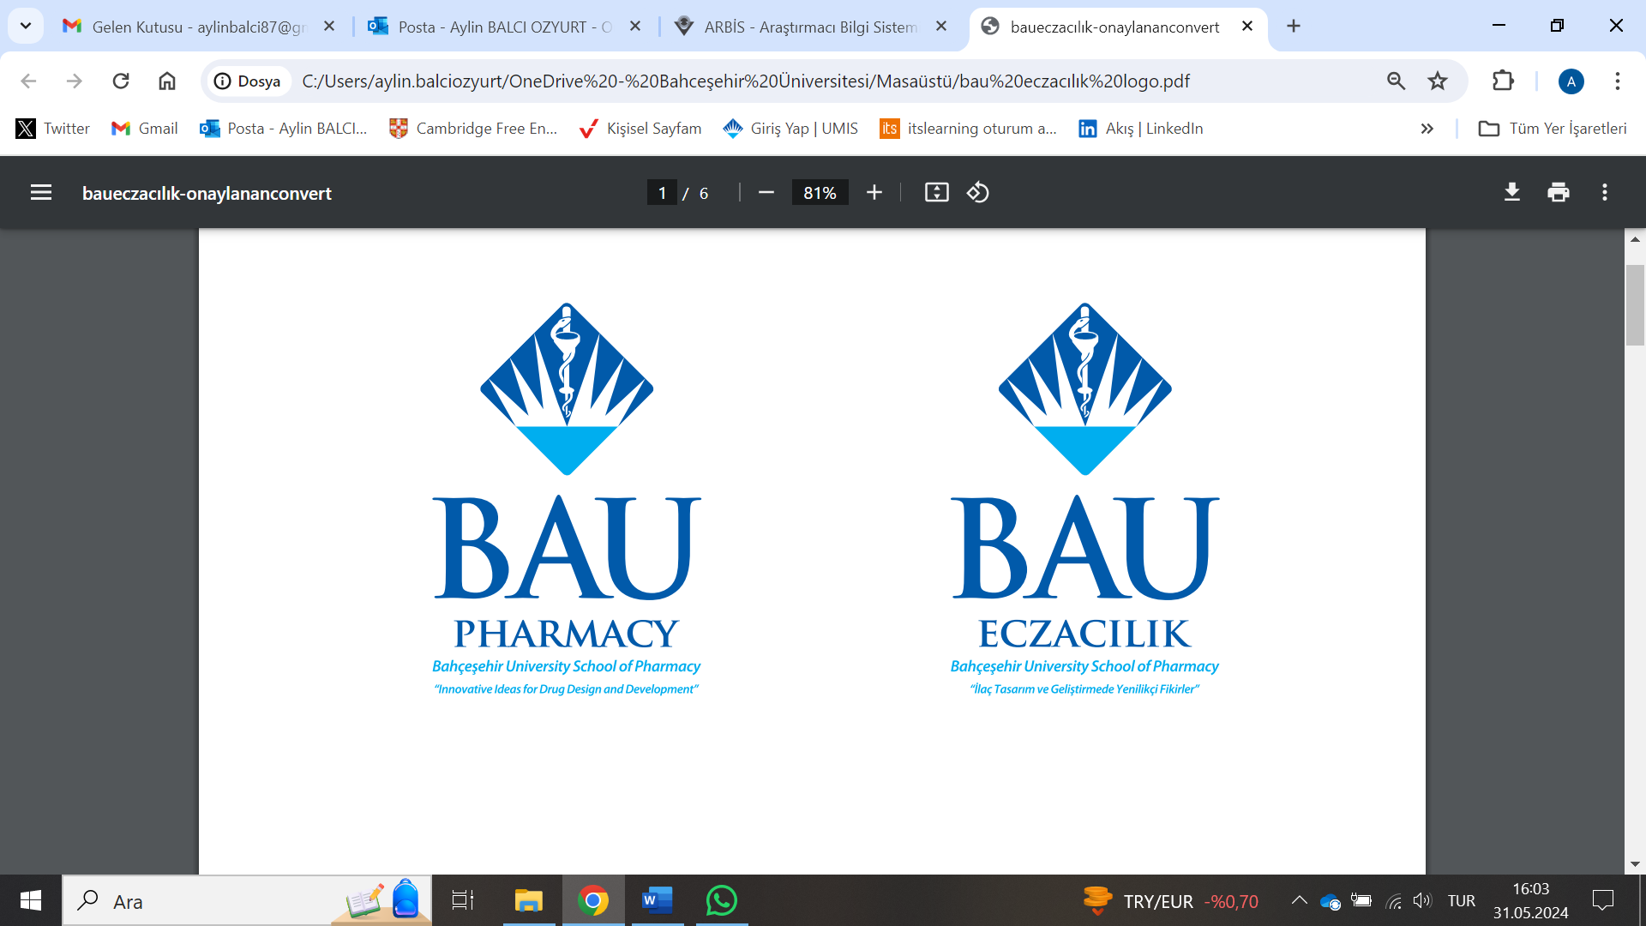

Photo

REPUBLIC OF TURKIYE

BAHÇEŞEHİR UNIVERSITY

SCHOOL OF PHARMACY

INTERNSHIP NOTEBOOK
PHAR 4999 INTERNSHIP-II
HOSPITAL PHARMACY

- Work reports must be filed daily throughout the duration of the internship per the attached report format.
- Work reports must be signed and stamped daily by the supervising pharmacist.
- At the end of the internship period, the Internship Benchmark Report must be filed by the intern and approved (via stamp and signature) by the supervising pharmacist.
- All reports must be completed digitally and only printed for signing and stamping. Please do not deliver hand-written reports.
- Disciplinary action will be taken for students who are found to have plagiarized, AI-generated, purchased third party services, or otherwise engaged in unethical conduct to write their report forms.
- At the end of the internship period, an Internship Evaluation Form must be completed by the supervising pharmacist and delivered by hand to the department secretariat in a sealed envelope.
- Deadlines for internship reports and evaluation forms will be announced by the department during the Fall semester. The final documents that must be submitted are as follows:
  - The student internship report, containing daily Work Reports and the Internship Benchmark Report bound together as a single book.
  - The Internship Evaluation Form, to be filed and delivered in a sealed envelope by the supervising pharmacist.

REPUBLIC OF TURKIYE

BAHÇEŞEHİR UNIVERSITY

SCHOOL OF PHARMACY

INTERNSHIP-II
HOSPITAL PHARMACY REPORT

NAME:
STUDENT NO:
SIGNATURE (INTERN):
INTERNSHIP PLACE:
INTERNSHIP START AND END DATE:
INTERNSHIP DURATION (TOTAL WORK DAYS):
STAMP AND SIGNATURE (SUPERVISING PHARMACIST):
*Every page of the report, including the cover, must be signed and stamped individually

DAILY REPORT
Date:
Working Hours:
Daily Practices and Outcomes:

*

*

*

Daily Approval of the Responsible Pharmacist

DAILY REPORT
Date:
Working Hours:
Daily Practices and Outcomes:

*

*

*

*

Daily Approval of the Responsible Pharmacist

DAILY REPORT
Date:
Working Hours:
Daily Practices and Outcomes:

*

*

*

*

Daily Approval of the Responsible Pharmacist

DAILY REPORT
Date:
Working Hours:
Daily Practices and Outcomes:

*

*

*

*

Daily Approval of the Responsible Pharmacist

DAILY REPORT
Date:
Working Hours:
Daily Practices and Outcomes:

*

*

*

*

Daily Approval of the Responsible Pharmacist

DAILY REPORT
Date:
Working Hours:
Daily Practices and Outcomes:

*

*

*

*

Daily Approval of the Responsible Pharmacist

DAILY REPORT
Date:
Working Hours:
Daily Practices and Outcomes:

*

*

*

*

Daily Approval of the Responsible Pharmacist
DAILY REPORT
Date:
Working Hours:
Daily Practices and Outcomes:

*

*

*

*

Daily Approval of the Responsible Pharmacist

DAILY REPORT
Date:
Working Hours:
Daily Practices and Outcomes:

*

*

*

*

Daily Approval of the Responsible Pharmacist

DAILY REPORT
Date:
Working Hours:
Daily Practices and Outcomes:

*

*

*

*

Daily Approval of the Responsible Pharmacist

DAILY REPORT
Date:
Working Hours:
Daily Practices and Outcomes:

*

*

*

*

Daily Approval of the Responsible Pharmacist

DAILY REPORT
Date:
Working Hours:
Daily Practices and Outcomes:

*

*

*

*

Daily Approval of the Responsible Pharmacist

DAILY REPORT
Date:
Working Hours:
Daily Practices and Outcomes:

*

*

*

*

Daily Approval of the Responsible Pharmacist

DAILY REPORT
Date:
Working Hours:
Daily Practices and Outcomes:

*

*

*

*

Daily Approval of the Responsible Pharmacist

DAILY REPORT
Date:
Working Hours:
Daily Practices and Outcomes:

*

*

*

*

Daily Approval of the Responsible Pharmacist

DAILY REPORT
Date:
Working Hours:
Daily Practices and Outcomes:

*

*

*

*

Daily Approval of the Responsible Pharmacist

DAILY REPORT
Date:
Working Hours:
Daily Practices and Outcomes:

*

*

*

*

Daily Approval of the Responsible Pharmacist

DAILY REPORT
Date:
Working Hours:
Daily Practices and Outcomes:

*

*

*

*

Daily Approval of the Responsible Pharmacist

DAILY REPORT
Date:
Working Hours:
Daily Practices and Outcomes:

*

*

*

*

Daily Approval of the Responsible Pharmacist

DAILY REPORT
Date:
Working Hours:
Daily Practices and Outcomes:

*

*

*

*

Daily Approval of the Responsible Pharmacist

DAILY REPORT
Date:
Working Hours:
Daily Practices and Outcomes:

*

*

*

*

Daily Approval of the Responsible Pharmacist

DAILY REPORT
Date:
Working Hours:
Daily Practices and Outcomes:

*

*

*

*

Daily Approval of the Responsible Pharmacist

DAILY REPORT
Date:
Working Hours:
Daily Practices and Outcomes:

*

*

*

*

Daily Approval of the Responsible Pharmacist

DAILY REPORT
Date:
Working Hours:
Daily Practices and Outcomes:

*

*

*

*

Daily Approval of the Responsible Pharmacist
DAILY REPORT
Date:
Working Hours:
Daily Practices and Outcomes:

*

*

*

*

Daily Approval of the Responsible Pharmacist

DAILY REPORT
Date:
Working Hours:
Daily Practices and Outcomes:

*

*

*

*

Daily Approval of the Responsible Pharmacist

DAILY REPORT
Date:
Working Hours:
Daily Practices and Outcomes:

*

*

*

*

Daily Approval of the Responsible Pharmacist

DAILY REPORT
Date:
Working Hours:
Daily Practices and Outcomes:

*

*

*

*

Daily Approval of the Responsible Pharmacist

DAILY REPORT
Date:
Working Hours:
Daily Practices and Outcomes:

*

*

*

*

Daily Approval of the Responsible Pharmacist

DAILY REPORT
Date:
Working Hours:
Daily Practices and Outcomes:

*

*

*

*

Daily Approval of the Responsible Pharmacist

BAHÇEŞEHİR UNIVERSITY
SCHOOL OF PHARMACY
PER THE FACULTY’S INTERNSHIP LEARNING BENCHMARKS, THE FOLLOWING TOPICS MUST BE DEFINED AND DESCRIBED IN THE INTERN’S FINAL REPORT
The sections below must be fully explained by the intern and approved (via stamp and signature) by the supervising pharmacist.
INTERNSHIP II PHAR4999 - HOSPITAL PHARMACY INTERNSHIP
- Explain the following basic information about the hospital where the internship is being conducted:
a. The type of hospital (university, state, high specialization, training and research, private, etc.)
b. The number and names of hospital departments; the number and names of outpatient clinics; and the number of intensive care units
- Explain the following basic information about the hospital pharmacy where the internship is being conducted:
a. The number of pharmacists, clinical pharmacy specialists, and pharmacology specialists in the hospital pharmacy
b. The roles and responsibilities of a pharmacist as a healthcare professional in the hospital pharmacy
c. The number, qualifications, and responsibilities of auxiliary personnel
d. The location of the hospital pharmacy within the hospital; its sections and their functions; the storage areas belonging to the pharmacy and their appropriate locations within the hospital; and the procedures for transferring medications between storage areas, the pharmacy, and hospital departments
e. The classification, shelving, and storage system of medications
f. The equipment and devices used in the hospital pharmacy
g. The working hours of the hospital pharmacy and the on-call duty system
h. The average number of prescriptions prepared daily in the hospital pharmacy
i. The regulations governing all hospital practices and those that hospital pharmacy staff must comply with
j. The procurement procedures for medicines and medical devices, annual tender procedures, and tender laws, as well as the pharmacist’s role in the decision-making process for purchases
k. The documentation and recording procedures for purchased medicines and medical devices
- Explain the processes related to the preparation and distribution of medicines and medical devices listed in prescriptions and physician order/request forms:
a. The medication distribution system used in the hospital (unit-dose, etc.)
b. The compatibility and connection of these systems with the free market and other hospitals, as well as their relationship with the provision system
c. The components of prescriptions and physician order/request forms
d. The steps involved in the verification and preparation of medicines, medical devices, and medical consumables listed in prescriptions and physician order/request forms
- Explain the procedures for the registration, storage, and distribution of narcotic drugs.
- Describe the procedures for maintaining records of medicines within the scope of purple and orange prescriptions and their submission to the relevant institution.
- List the committees in which pharmacists participate or hold membership (e.g., infection control committee, etc.).
- Explain the necessary safety precautions when working with hazardous drugs (e.g., cytotoxic drugs).
- Describe the preparation stages of intravenous solutions and cytotoxic drugs and the critical factors to be considered.
- Evaluate Total Parenteral Nutrition (TPN) Units and the responsibilities of pharmacists in these units.

